3.2 Compare the interest earned by $10,000 for five years at 10% simple interest with that earned by the same amount for five years at 10% compounded annually.

GIVENS
Principal = $10,000
Interest rate = 10%
Number of Years = 5

DETERMINE
Compare the interest earned using simple interest and interest compounded annually.

ANALYSIS

Simple Interest
Step 1: Multiply the principal, the interest rate, and the number of years.

Interest = $10,000 x .1 x 5 = $5,000

Step 2: The formula to find the future value with interest is Amount = Principal + Interest

Amount = $10,000 + $5,000
Final Future Value at 10% simple interest is $15,000

Interest Compounded Annually

A= P(1 + rn)n⋅t | A = total amount  P = principal  r = interest rate  n = # times compounded each year  t = time (years)
P=$10,000 , r=10% , n=1 and t=5 years

$16,105.10 = $10,000 + Interest = $6,105.10
Final Future Value at 10% annually compounded interest is $6,105.10

CONCLUSION
 | Simple Interest | Compound Interest
Starting | $10,000.00 | $10,000.00
Year 1 | $11,000.00 | $11,000.00
Year 2 | $12,000.00 | $12,100.00
Year 3 | $13,000.00 | $13,310.00
Year 4 | $14,000.00 | $14,641.00
Year 5 | $15,000.00 | $16,105.10

During the span of five years, interest that compounds annually will earn an additional $1,105.10

3.13 For an interest rate of 13% compounded annually, determine the following.
(a) How much can be lent now if $12,000 will be repaid at the end of four years?
(b) How much will be required in five years to repay a $30,000 loan received now?

GIVENS

DETERMINE

ANALYSIS

CONCLUSION

3.19 If you desire to withdraw the amounts given in Table P3.19 over the next five years from a savings account that earns 7% interest compounded annually, how much do you need to deposit now?

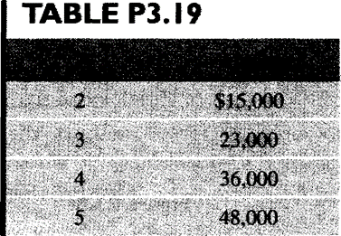

GIVENS

DETERMINE

ANALYSIS

CONCLUSION

3.39 Five annual deposits in the amounts of $10,000, $8,000, $6,000, $4,000, and $2,000, in that order, are made into a fund that pays interest at a rate of 8% compounded annually. Determine the amount in the fund immediately after the fifth deposit.

GIVENS

DETERMINE

ANALYSIS

CONCLUSION

3.51 Find the equivalent present worth of the cash receipts where i = 8%. In other words, how much do you have to deposit now (with the second deposit in the amount of $200 at the end of the first year) so that you will be able to withdraw $200 at the end of second year, $120 at the end of third year, and so forth if the bank pays you an 8% annual interest on your balance?

GIVENS

DETERMINE

ANALYSIS

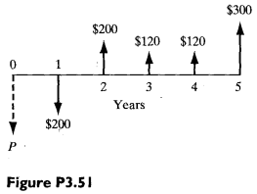
CONCLUSION

